High Level Design for Body Language Application

**What problem does this application solved?**

Body Language is an app that will convey emotion through text based communication based on user data, so your recipient won’t interpret your messages incorrectly. This will be done by the app predicting your mood or emotion, or if incorrect, by the user selecting the mood they are feeling or trying to convey. The app will then change the text message’s font and background color to better show the person’s mood, or the user can choose from a list of pre-set moods/combinations. This data from the user will be stored and sent to Body Language for improving prediction, so over time, a database will grow and develop a correlation between what font and color combo commonly is paired with certain phrases. A color will also be assigned, or chosen by the user to add to the emotional effect of the text.

**General Functionality:**

* A user logs into the application.
* BodyLang App page displays
* User chooses Text or Chat
* Users enters I a sentence
* The sentence is sent to the Watson API
* Results from the Watson API are sent to a function where the “emotion” is calculated.
* This calculated emotion has a CSS style associated with it.
* The CSS style is applied to the text or chat
* The emotion associated with the style( font, color) is stored in the database for each user
* User can access history of emotions

**Technical Requirements:**

* Front end UI ( to login)
* Front end UI ( to enter text or chat)
* Middleware to send and receive data from Watson API
* Backend - build Database
* Technology - React
* Technology - Mongo DB(?)

**Resources:**

* **Tanner Martin:**
  + **Front end- BodyLang App**
* **Christian Fraijo:**
  + **API Call to Watson**
* **Denise Ballard:**
  + **Login**
  + **Database work**
* **Chris Choi:**
  + **Login**
  + **Frontend**

**Deliverables:**

|  |  |  |  |
| --- | --- | --- | --- |
| **Date** | **Resource** | **Deliverable** | **Status** |
| **02-24-2018** | **Denise with Team** | High level Design/Wireframe and workflow |  |
| **O2-26-2018** | **Team** | Research Completed |  |
| **03-03-2018** | **Chris C** | Login Front end |  |
| **03-03-2018** | **Denise B** | Login Backend |  |
| **03-03-2018** | **Tanner/Christian** | Front Page Renders for App( IM and Chat) |  |
| **03-03-2018** |  | Input can be Accepted |  |
| **03-03-2018** |  | Successful call to Watson API |  |
| **03-03-2018** |  | Function to calculate Tone |  |
| **03-03-2018** |  | Data display on Page |  |
|  |  |  |  |
| **03-10-2017** |  | Data for user populates database |  |
| **03-10-2017** |  | User history displays |  |
| **03-10-2017** |  | Update Frontend with enhancements |  |
| **03-10-2017** |  | Troubleshooting Issues |  |
| **03-10-2017** |  | Testing |  |
|  |  |  |  |
| **03-17-2018** |  | Final updates for Project Presentation |  |
|  |  | Power Point completed |  |
|  |  | Updates to business plan |  |
|  |  | Deployment to heroku |  |
|  |  |  |  |
|  |  |  |  |
|  |  |  |  |
| **03-17-2018** | **Team Presents** |  |  |

**TRELLO- Screen capture**



**Diagram of Workflow**

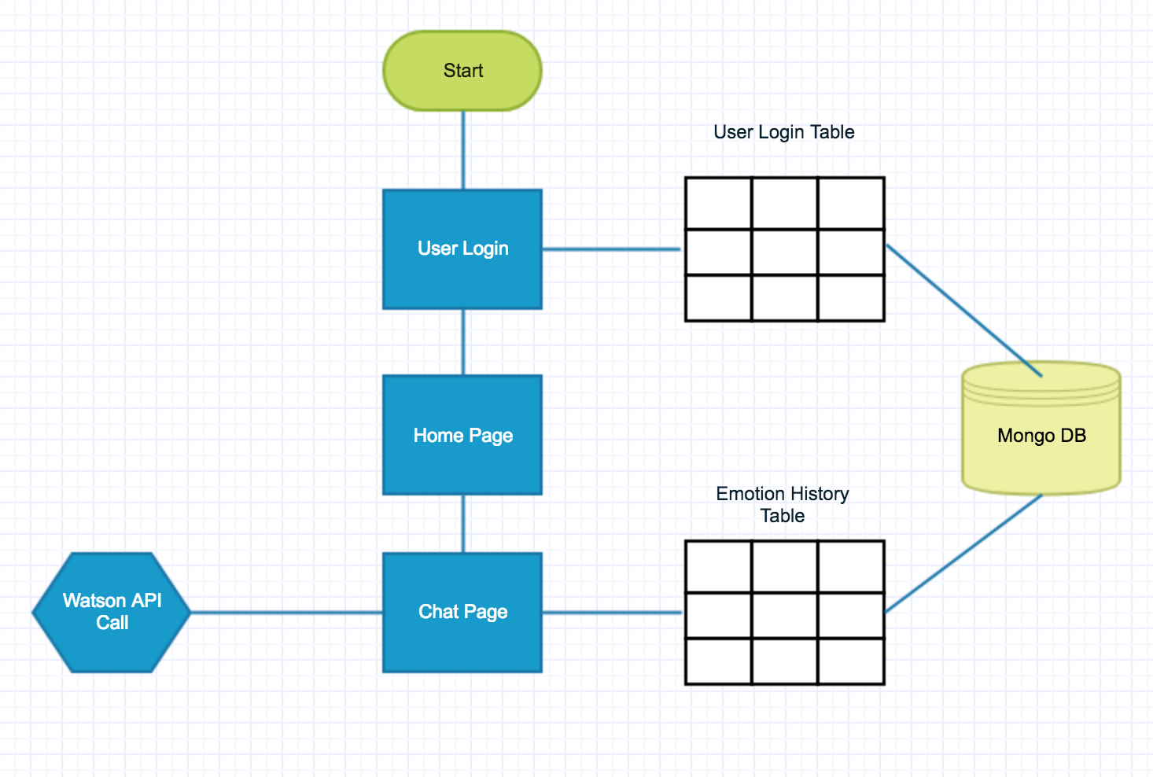

**----------------------------------------------**

Steps:

1. User logins
   1. If Login is not successful- display error message
   2. If Login is successful
      1. Add user to database
      2. Display Body Lang App
2. Enter Data into BodyLang App
   1. Chat data
   2. IM data
3. Send Data to Watson API
   1. Watson API sends data to=>?
   2. Watson output is =>?
4. Display value = emotion ( on main page?)
5. Apply style to text
   1. Where is style stored?
      1. CSS
      2. Database call
      3. *How is style figured out and applied?*

Question: Can this = MVP and have working by 03-03-2017